Fleet Hospital and Community Friends 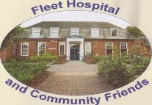
Annual Subscription form. (this is due in April of each year) Charity No. 1169526
Name:…………………………………………………………………………………………………………………………………………
Address……………………………………………………………………………………………………………………………………….
……………………………………………………………………………………………………………………………………………………
Email address if available……………………………………………………………………………………………………………..
I am pleased to enclose my subscription of £….. to the Friends of Fleet Hospital and Community.
Signed ………………………………
If you are a tax payer and wish to make a Gift Aid donation, please fill out the att. form.
If you have already filled in the new form then please indicate that you still happy for this to continue.
I agree that Gift Aid can still be collected . Please tick box.
Return to Mrs. Harrie Glossop, 8 The Flats, Blackwater, GU17 OAN
Tel. 01276 5021484 Email: harrieowen48@gmail.com

Friends of Fleet Hospital and Community 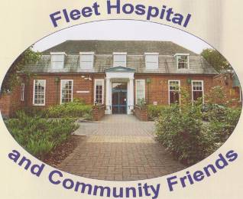
Annual Subscription form. (this is due in April of each year) Charity No. 1169526
Name:…………………………………………………………………………………………………………………………………………
Address……………………………………………………………………………………………………………………………………….
……………………………………………………………………………………………………………………………………………………
Email address if available……………………………………………………………………………………………………………..
I am pleased to enclose my subscription of £….. to the Friends of Fleet Hospital and Community.
Signed ………………………………
If you are a tax payer and wish to make a Gift Aid donation, please fill out the att. form.
If you have already filled in the new form then please indicate that you still happy for this to continue.
I agree that Gift Aid can still be collected . Please tick box.
Return to Mrs. Harrie Glossop, 8 The Flats, Blackwater, GU17 OAN
Tel. 01276 502484 Email: harrieowen48@gmail.com

